MEDIA RELEASE | Contact: Peter Jarvis
MEDIA RELEASE | Storm Interface
MEDIA RELEASE | Phone: +44 (0)1895 456200
MEDIA RELEASE | Email: sales@storm-interface.com
London, England. January 2016 | Web: www.storm-interface.com
A New Era of Accessibility

In compliance with ADA Standards for Accessible Design, new US Department of Transport regulations come into effect during 2016. These new mandates are intended to increase accessibility for those with sensory or mobility impairment.
Sight impaired travelers will be able to access information and services via kiosks and ticketing machines by connection of a personal headset.
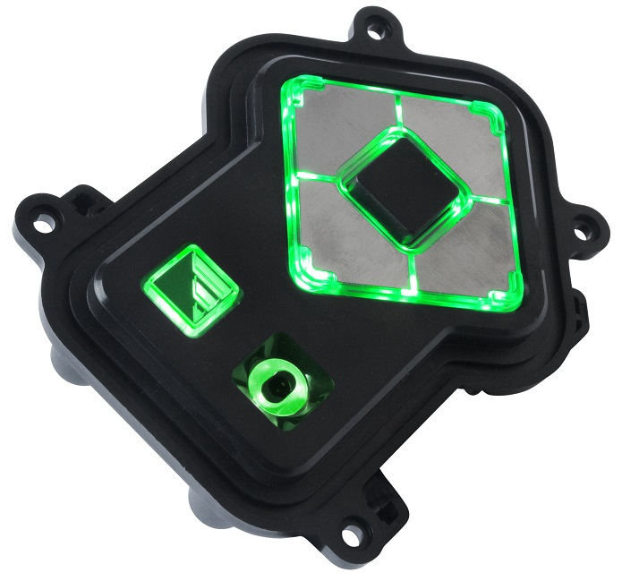
The host system will detect the connection of a headset as a signal to begin an audible summary of the information and services presented on the kiosk’s display screen or touch screen. A highly tactile keypad will enable those with no vision or low vision to navigation through those audible menus and make selections by a simple key press.
This Audio Navigation technology will also help non-readers. Some agencies consider that an inability to read may be the world’s most common form of disability; regardless of whether such inability stems from physiological, educational, cultural or cognitive reasons.
Storm Interface has been working with lead agencies and kiosk manufacturers to provide practical and affordable assistive technology solutions. They manufacture the Nav-Pad™ keypads currently used in many applications, including the Global Entry kiosks located in the immigration halls at most major US airports.
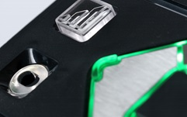
Storm has also been working with its long-time partner NCR Corporation in the development of a new generation of intuitive Audio-Navigation solutions for use in travel and self check-out applications. These activities have lead to the introduction of a new ADA compliant assistive keypad: the Audio-Nav. The Audio-Nav is easy to install and easy to use. It features tactile identifiers (tac-idents) to assist those with impaired vision. The ‘tac-idents’, keytops and connectors also feature integral illumination to assist those with partial vision or any residual light/dark perception.
Figure 2. Integral illumination helps those with impaired vision
The new Audio-Nav keypad also includes an integrated sound processor and headset connection to make audio communication with the host system as clear and intuitive as it can be. It is intended for use in conjunction with compliant text-to-speech applications.

About Storm Interface
Storm Interface is an award winning, UK based, manufacturer of human interface devices.
The Storm range of secured, sealed and toughened data entry devices are field proven and laboratory tested. They are constructed to survive in the most demanding applications and environments. Since 1986, Storm’s design, technology and manufacturing quality have established Storm products as the industry standard for durability and reliability.
www.storm-interface.com

About NCR Corporation
NCR Corporation (NYSE: NCR) is the global leader in consumer transaction technologies, turning everyday interactions with businesses into exceptional experiences. With its software, hardware, and portfolio of services, NCR enables more than 550 million transactions daily across retail, financial, travel, hospitality, telecom and technology, and small business. NCR solutions run the everyday transactions that make your life easier.
NCR is headquartered in Duluth, Georgia with over 30,000 employees and does business in 180 countries. NCR is a trademark of NCR Corporation in the United States and other countries.

